UnGuided Transmission

* An unguided transmission transmits the electromagnetic waves without using any physical medium. Therefore it is also known as **wireless transmission**.
* In unguided media, air is the media through which the electromagnetic energy can flow easily.

Unguided transmission is broadly classified into three categories:

Radio waves

* Radio waves are the electromagnetic waves that are transmitted in all the directions of free space.
* Radio waves are omnidirectional, i.e., the signals are propagated in all the directions.
* The range in frequencies of radio waves is from 3Khz to 1 khz.
* In the case of radio waves, the sending and receiving antenna are not aligned, i.e., the wave sent by the sending antenna can be received by any receiving antenna.
* An example of the radio wave is **FM radio**.

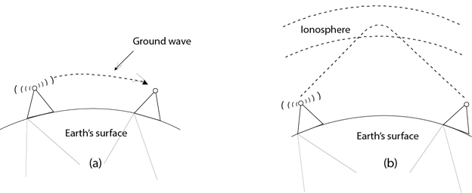

**Applications Of Radio waves:**

* A Radio wave is useful for multicasting when there is one sender and many receivers.
* An FM radio, television, cordless phones are examples of a radio wave.

**Advantages Of Radio transmission:**

* Radio transmission is mainly used for wide area networks and mobile cellular phones.
* Radio waves cover a large area, and they can penetrate the walls.
* Radio transmission provides a higher transmission rate.

Microwaves

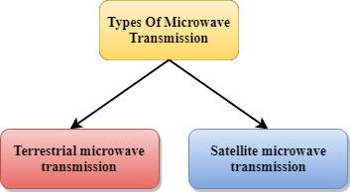

Microwaves are of two types:

* Terrestrial microwave
* Satellite microwave communication.

Terrestrial Microwave Transmission

* Terrestrial Microwave transmission is a technology that transmits the focused beam of a radio signal from one ground-based microwave transmission antenna to another.
* Microwaves are the electromagnetic waves having the frequency in the range from 1GHz to 1000 GHz.
* Microwaves are unidirectional as the sending and receiving antenna is to be aligned, i.e., the waves sent by the sending antenna are narrowly focussed.
* In this case, antennas are mounted on the towers to send a beam to another antenna which is km away.
* It works on the line of sight transmission, i.e., the antennas mounted on the towers are the direct sight of each other.

**Characteristics of Microwave:**

* **Frequency range:** The frequency range of terrestrial microwave is from 4-6 GHz to 21-23 GHz.
* **Bandwidth:** It supports the bandwidth from 1 to 10 Mbps.
* **Short distance:** It is inexpensive for short distance.
* **Long distance:** It is expensive as it requires a higher tower for a longer distance.
* **Attenuation:** Attenuation means loss of signal. It is affected by environmental conditions and antenna size.

**Advantages Of Microwave:**

* Microwave transmission is cheaper than using cables.
* It is free from land acquisition as it does not require any land for the installation of cables.
* Microwave transmission provides an easy communication in terrains as the installation of cable in terrain is quite a difficult task.
* Communication over oceans can be achieved by using microwave transmission.

**Disadvantages of Microwave transmission:**

* **Eavesdropping:** An eavesdropping creates insecure communication. Any malicious user can catch the signal in the air by using its own antenna.
* **Out of phase signal:** A signal can be moved out of phase by using microwave transmission.
* **Susceptible to weather condition:** A microwave transmission is susceptible to weather condition. This means that any environmental change such as rain, wind can distort the signal.
* **Bandwidth limited:** Allocation of bandwidth is limited in the case of microwave transmission.

Satellite Microwave Communication

* A satellite is a physical object that revolves around the earth at a known height.
* Satellite communication is more reliable nowadays as it offers more flexibility than cable and fibre optic systems.
* We can communicate with any point on the globe by using satellite communication.

**How Does Satellite work?**

The satellite accepts the signal that is transmitted from the earth station, and it amplifies the signal. The amplified signal is retransmitted to another earth station.

**Advantages Of Satellite Microwave Communication:**

* The coverage area of a satellite microwave is more than the terrestrial microwave.
* The transmission cost of the satellite is independent of the distance from the centre of the coverage area.
* Satellite communication is used in mobile and wireless communication applications.
* It is easy to install.
* It is used in a wide variety of applications such as weather forecasting, radio/TV signal broadcasting, mobile communication, etc.

**Disadvantages Of Satellite Microwave Communication:**

* Satellite designing and development requires more time and higher cost.
* The Satellite needs to be monitored and controlled on regular periods so that it remains in orbit.
* The life of the satellite is about 12-15 years. Due to this reason, another launch of the satellite has to be planned before it becomes non-functional.

Infrared

* An infrared transmission is a wireless technology used for communication over short ranges.
* The frequency of the infrared in the range from 300 GHz to 400 THz.
* It is used for short-range communication such as data transfer between two cell phones, TV remote operation, data transfer between a computer and cell phone resides in the same closed area.

**Characteristics Of Infrared:**

* It supports high bandwidth, and hence the data rate will be very high.
* Infrared waves cannot penetrate the walls. Therefore, the infrared communication in one room cannot be interrupted by the nearby rooms.
* An infrared communication provides better security with minimum interference.
* Infrared communication is unreliable outside the building because the sun rays will interfere with the infrared waves.